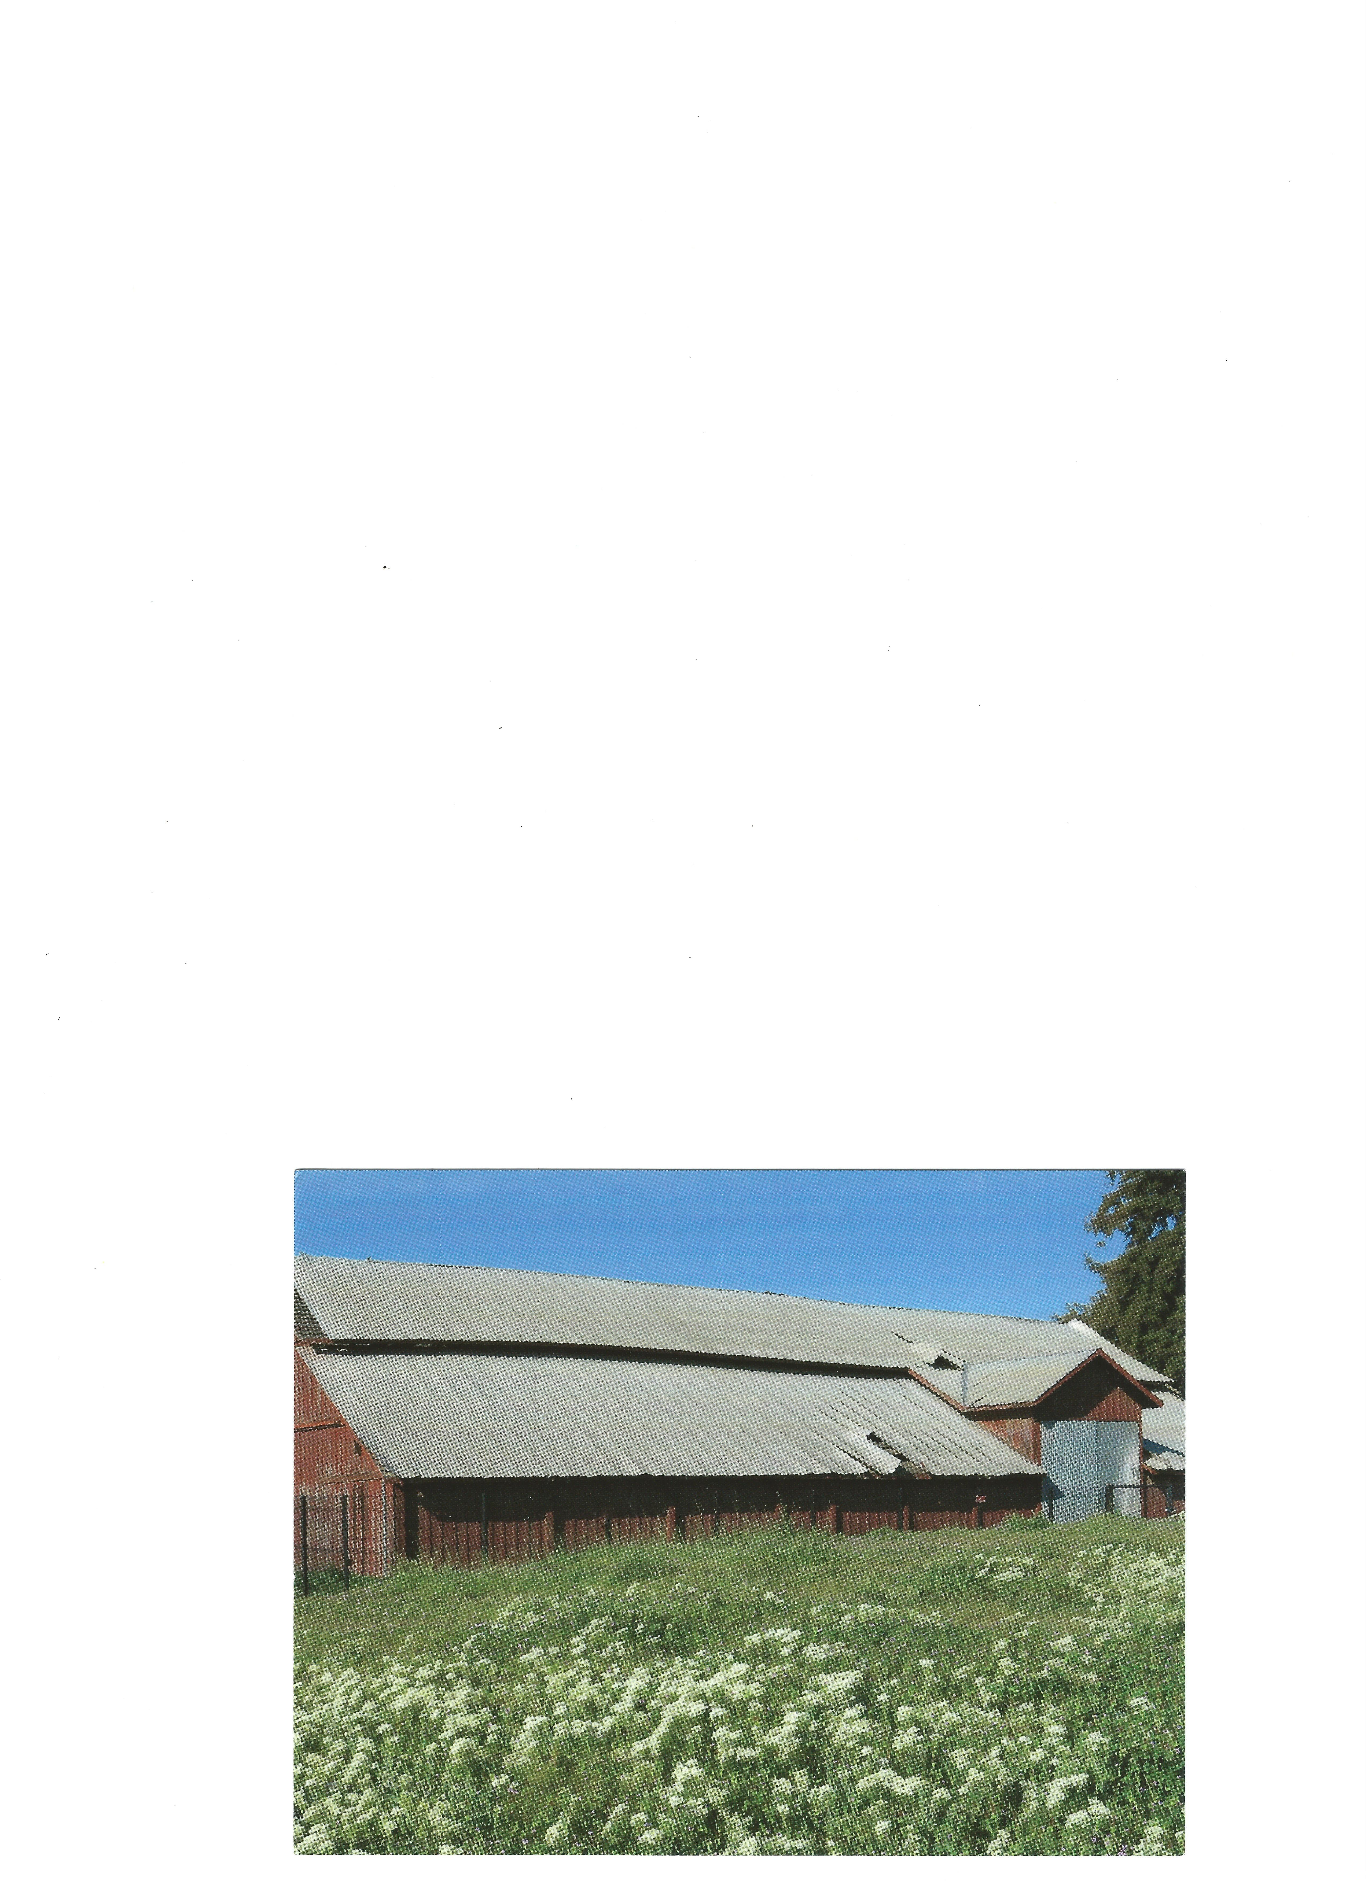
Under the eves…
April 2017
The Miller Red Barn Newsletter
Volume 1 Issue 5

In our last newsletter…
Henry had just arrived in San Francisco. It was rough and expensive. The question for Henry at this point was what to do. He had planned to go to the gold fields and make his fortune. However, he could not afford the tools for gold panning. Remember that a shovel was $15-$25, a tin pan was $20, a pair of boots was at least $40, and Henry only had $6 dollars when he arrived. Henry was not dumb. Having experienced the hardships of getting to California and, on landing seeing the price of food and land. Henry realized that if he were going to make his fortune it would not be by panning for gold.

On Henry’s first day in San Francisco, he left the ship and set out to find a job. “I asks a man where is a butcher shop,” he later stated. The man pointed to a shack on a hill near where California and Kearney Streets are today. “I finds a man sitting on a box in front of a lean- to. Flies were buzzing around him. He was reading a newspaper, which had come on the boat. He took no notice of me, so I coughed. When he looked over the top of the papers I says, “I just come on the boat; I am a butcher and wants a job.” He refused Henry, and Henry

moved on. Later that day he took a job washing dishes. He had his start.

Henry did not wash dishes very long, and he soon knew the city. He met a man named Edward Barron, who had a butcher shop at the head of Dupont Street (Grant Avenue today). Henry was immediately employed butchering sheep for Barron. He again worked for small wages, as he had in New York, and, to save the price of a room, he slept behind the slaughterhouse. He did his own cooking from the scraps. On occasion, he would splurge and eat at a Chinese restaurant. There, he could get a steak, potato and a cup of coffee for a dollar.

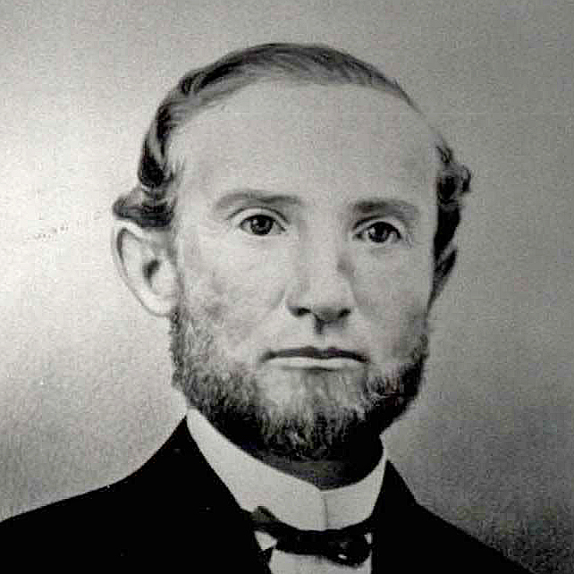
Henry Miller 1870*

Fire was common in San Francisco between 1850 and 1853. Where tents went up in smoke daily and the remaining poor construction set the stage for six total burndowns of the city. After the fire of June 1851, Henry was able to go out on his own. He leased a lot on Jackson Street between Dupont and Kearny. He built a one-story building; got some hooks, found a chopping block, bought some calves, and set up his shop. Henry slaughtered the calves and packed them on his back

to the other butchers from North Beach to Clark’s Point. He started his wholesale business on the first day of business in his own shop.1

1Edited by Charles Sawyer, Interviews by Ralph Milliken, One Man Show Henry Miller in the San Joaquin, (Los Banos: Ralph Milliken Museum Society, 2003)
*Photo courtesy of the Ralph Milliken Museum Society, Los Banos, CA

I hope that you enjoyed reading about how Henry Miller started his wholesale business in San Francisco. In the next issue of Under the eves… Henry Miller meets Charles Lux and empire starts to grow

Our next fund raising event is Saturday, June 17, 2017.
For more information, follow us on Facebook, just search
The Miller Red Barn Association.

Volunteers are joyfully welcomed. Questions and comments are always welcome. Contact me (Patti Perino) at 408-410-1495 or email at millerredbarn@outlook.com

